RADNI LISTIĆ ZA NASTAVNIKA

LESSON 1
ACTIVITY 1 – WARM-UP
Flipped classroom 1 – Quiz (In class)
- Where was Charles Dickens born?
- In which century did he live?
- What genre of writing is Dickens most famous for?
- Which city did Dickens mostly write about?
- Can you name at least 4 titles of his works?

Flipped Classroom 2 – A video
http://bit.ly/3XE4QFh
In class - Say:
3 things you have learned about Charles Dickens
2 things you find interesting
1 thing you would like to find out

ACTIVITY 3 AND 4 - While Reading Activities (Answer the questions)
Oxford Reading Club platforma:
E-naslov Oliver Twist stranica 107.
E-naslov Great Expectations stranica 91.

LESSON 2
ACTIVITY 2 Persuade your partner
These phrases might help you:
Why don’t you think about (consider something)…
It might be a good idea to…
Perhaps you could…
I would appreciate it if, (+Past Simple)
I can assure/guarantee you that…
Surely you have to agree that…
ACTIVITY 4 Book Review – Guidelines
Choose a title to catch the reader's attention
PARAGRAPH 1 - INTRODUCTION
Give your opinion of the book for the first time and some background information about the book.
PARAGRAPH 2
Briefly describe the plot and characters (use the present tense).
PARAGRAPH 3
Say why you liked the book and mention something you did not like.
PARAGRAPH 4
Restate your opinion of the book.

EXAMPLE
If you are hungry for a good book, read on!
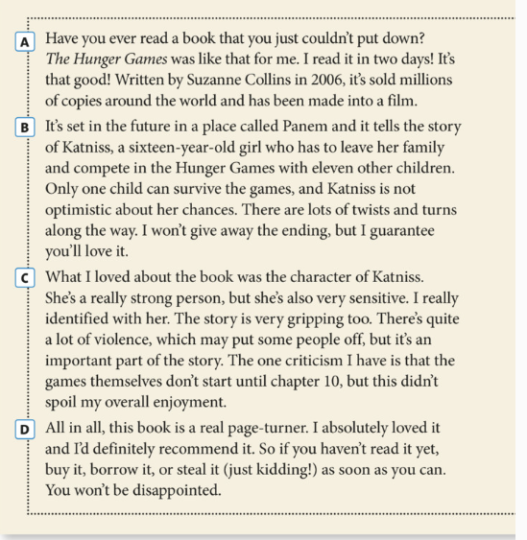
(Solutions 3rd Edition Intermediate, Student’s book, OUP)
ACTIVITY 5 Checklist – Self-assessment or peer-assessment
Have you…
- given your review a title and an interesting introduction?
- used an appropriate style?
- given your article a logical structure?
- used the present tense to describe the plot and characters?
- checked your grammar and spelling?

INTERNET PROJECT
Itinerary plan:
Describe what will happen on each day.
Include:
- arrival and departure times
- details of accommodation
- restaurants/places to grab a bite
- attractions to visit
- shows/events to see
Remember to make it sound as attractive as possible.

Sources:
Oxford Reading Platform;
Solutions 3rd Edition Intermediate Student's book, OUP;
https://www.youtube.com/watch?v=unKuZ2wlNdw
https://www.britannica.com/biography/Charles-Dickens-British-novelist
https://hr.padlet.com
https://www.youtube.com/watch?v=x9IQVofS43I
https://www.tripadvisor.co.uk/Attractions-g186338

